Project Proposal

- Title of the project:
Meeting Notes Analyzer

- Brief on the project:
The goal of this project is to build an AI-powered Meeting Notes Analyzer that converts a meeting transcript into structured insights using LangGraph workflow. The system should analyze the transcript and automatically generate:
- Key discussion topics
- Summary of the meeting
- Action items
- Task owners
- Priority level of tasks

- Deliverables of the project:
- An application to analyze meeting transcript and provide minutes of the meeting.
- Detailed instruction how to use the user interface of meeting analyzer .

- Resources:
- Data set source:

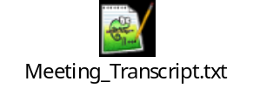
- Software:
- Visual Studio Code
- Jupyter Notebook
- Google Colab
- Github
- Streamlit
- Render

- LLM:
- gpt-4o-mini (Open-AI)

- Individual Details:
- Name : Abhijit Saha
- E-mail Id : abhijit250692@gmail.com
- Phone Number : +91 8549968520

- Milestones:

- Why AI-generated meeting note analyzer is important?

Organizations conduct multiple meetings every day, but it is often difficult to capture key decisions and action items. An AI-generated meeting note analyzer is important because it transforms raw conversations into searchable business intelligence, saves 10 to 30 minutes of post-meeting administrative work per session, and frees participants to stay fully engaged.

Full Engagement and Focus

- Participants stop splitting their attention between listening and typing, leading to more thoughtful contributions and faster decision-making.

Significant Time Savings

- Eliminates manual tasks like writing summaries, formatting notes, and extracting action items across Zoom, Microsoft Teams, and Google Meet.

Searchable Knowledge Base

- Converts spoken discussions into indexed transcripts and tagged topics, allowing teams to find exact quotes, decisions, or numbers without replaying long recordings.

Clear Accountability and Tracking

- Automatically assigns to-do steps, flags approvals, and tracks recurring responsibilities across follow-up sessions.

Better Institutional Memory

- Prevents knowledge from being lost when employees miss a call or leave the company, building a compounding library of searchable team history.

- Example Meeting Transcript:

John: We need to improve the website performance.
Sarah: Yes, page load time is too slow.
David: I will optimize the database queries this week.
Sarah: I will redesign the homepage layout.
John: Let's try to finish these tasks before Friday.

- Expected Output Example:

- Meeting Summary :

The team discussed improving website performance and reducing page load time.

- Key Topics :

1. Website performance

2. Database optimization

3. Homepage redesign

- Action Items :

1. Optimize database queries – David

2. Redesign homepage layout – Sarah

- Model building :

- Input Node :

The system should take a meeting transcript as input. The input can be a paragraph, a conversation transcript, or multiple speaker messages.

- Topic Extraction Agent :

This agent reads the transcript and identifies the main discussion topics. The output should be a list of key topics discussed in the meeting.

- Meeting Summary Agent :

This agent generates a short meeting summary explaining what the meeting was about. The summary should be concise and limited to 3–5 sentences.

- Action Item Extraction Agent :

This agent identifies tasks assigned during the meeting and extracts:

- Task description

- Person responsible (if mentioned)

If the owner is not mentioned, label it as 'Owner: Not specified'.

- Priority Classification Agent :

This agent determines the priority level of the meeting tasks. Possible outputs include:

- High Priority

- Medium Priority

- Low Priority

The agent should detect urgency from phrases like 'urgent', 'ASAP', 'by tomorrow', or 'this week'.
- Conditional Logic :

If no action items are detected, the workflow should skip the priority classification step and output 'No action items identified in this meeting.'

- Final Output Node :

The final node should combine outputs from all agents and generate a structured meeting report including:

1. Meeting Summary

2. Key Topics

3. Action Items

4. Task Owners

5. Priority Level

- Model architecture:

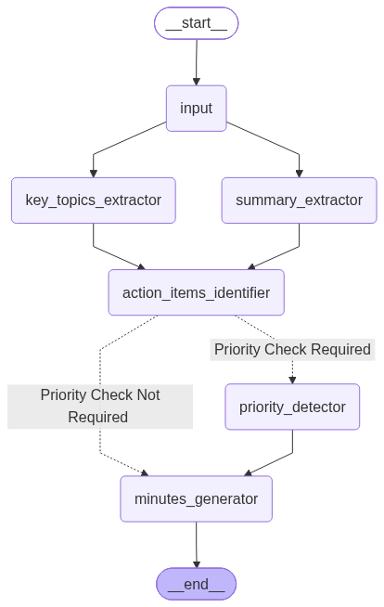

- Code:

Github : https://github.com/abhijit250692/Meeting-Note-Analyzer

- User Interface:

Render : https://meeting-note-analyzer.onrender.com/

